How to Play Battle Dome

Overview
Battle Dome is a text-based RPG. Players create characters with a class and weapon, and can face off against other players (PvP) or powerful monsters (PvE). (However, BD is not a roleplay-based room, and excessive roleplay is not what this room is for.) After each game, players gain loot to get stronger and can purchase items to help in battle.

Part 1: Getting Registered
To begin playing, you must create a character, which can be done by messaging a roomauth (User with +, %, @ or # next to their names). In your message, include a class and weapon of choice from the list below – don’t worry, these can be changed anytime outside of a game. Then, you can click the Highlight for games button in the roomintro to be notified when a game starts.

Note: You may not have more than one character in Battle Dome.

Classes
Classes are what determine your playstyle. Each has a different set of stats, abilities, and tools to help you fit your preferred playstyle.

- Bard: A support class that links with an ally to empower their buffs.
- Blacksmith: A defensive specialist in trapping and area denial.
- Cleric: A frail class dedicated to healing and supporting its allies.
- Dancer: An offensive support class with mastery over the turn order.
- Monk: A slow-burn offensive class that gets more powerful every turn.
- Paladin: The tank. Protects allies and has excellent survivability.
- Rifter: A glass-cannon chaotic class with explosive damage.
- Skirmisher: An evasive attacker with unparalleled mobility.

Weapons
Weapons have unique gimmicks that provide most of your attacking abilities and have the highest impact on your play experience. Pick one that interests you! Weapons are grouped into trios called Branches. You can view every Class and Weapon’s abilities on the homepage.

- Archer: Crossbow, Longbow, and Shortbow.
- Clairvoyant: Cards, Lunar Rod, and Orb.
- Dark: Athame, Scythe, and Totems.
- Dueler: Gladius, Quarterstaff, and Tonfa.
- Heavy: Axe, Hammer, and Tomahawk.
- Noble: Crown, Katana, and Rapier.
- Sorcerer: Shillelagh, Spellbook, and Talisman.

Part 2: Playing the Game

Joining a Game
To join a game, someone else will have to be hosting. When they open signups, click the join button to be put into the game. Soon, the signups will close, and a list of available modes will be given based on the number of players. To learn what the modes are, use /rfaq modes. Next, the host will ask for players to vote for a mode. The mode with the most votes is played. Once you level up a bit, ND can also be voted on (%wt ND in Ice Kyubs’s PMs to learn what it is).

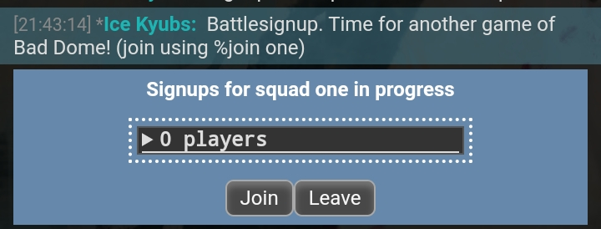

Reading the Player List
To figure out how to make sense of the game, first let’s take a look at the %info chart and learn about the stats and other information in it.

- # - Player number, as seen on the map. Player numbers are in turn order.
- Name - Player name (or monster name in PvE).
- Class/Weapon - Equipped class and weapon, along with their level.
- HP - Hit Points. At 0 HP, you die and are removed from the game.
- A - Attack: Added to the damage of physical moves.
- M - Magic: Added to the damage of magical moves.
- PD - Physical Defense: Subtracted from the damage of physical moves.
- MD - Magical Defense: Subtracted from the damage of magical moves.
- EVA - Evasions. Determines how likely it is for a player to dodge attacks.
- MP - Movement Points: How many tiles you can move in a turn.

The Turn Order (TO) below the player list shows the order in which all of the players in the game go. At the end of the TO, the order repeats.

Below the turn order is the Item List, displaying each player’s equipped items. You’ll be able to buy items with the gold and gems you earn from playing games.

Taking Your Turn: Moving
On your turn, the first thing you will need to do is make a movement action. You can only move as many tiles as you have MP, and you can’t move along diagonals. Generally, you’ll need to move into the range of your attack.
Dash can be used to let you move 1.5x your MP. Generally, you cannot dash and attack in the same turn.

To move, type %move letter, number. (ex: %move I,5)

Take into account the tile types of the map you are playing on. Tiles are marked with colored squares, and you can learn about them with %wt tilecolors or by viewing the glossary. Some tiles may impede your movement, so beware!

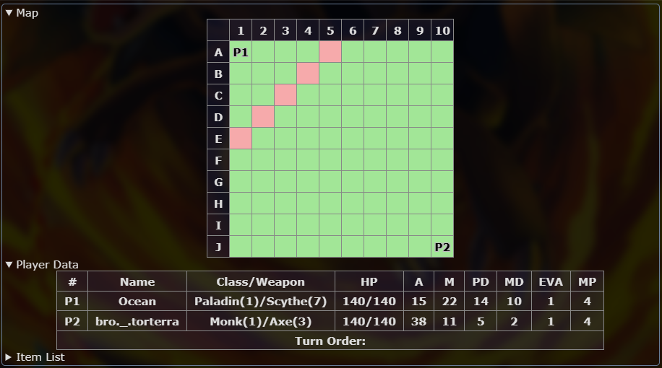

Here, it is Player 1's Turn. They have 4 MP, so they can move up to 4 tiles. The pink tiles display five different possible movements for Player 1.

Taking Your Turn: Attacking
Once you're in range of your opponent, you can attack! Information about an attack can be found in the homepage or by PMing Ice Kyubs %wt (ability).

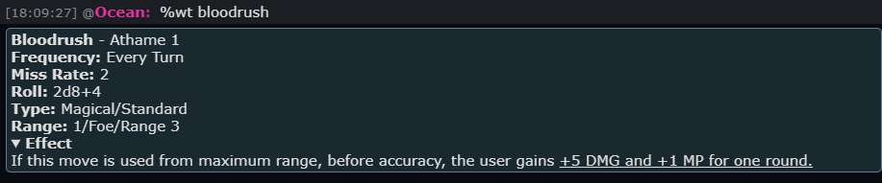

Like before, let’s break down the ability into each piece of information.

- Name - The name of the ability and the level that the weapon gets it.
- Frequency - How often you can use a move.
  - Every Turn - Can be used every turn, without any restrictions.
  - EoT - Can be used every other turn.
  - E3T - Can be used every three turns.
  - Twice - Can be used two times per game
  - Once - Can be used one time per game.
- Miss Rate (MR) - Determines how likely your move is to miss.
- Roll - The damage the attack will do on hit. The user’s Attack or Magic is usually added to this, and the target’s Physical Defense or Magical Defense is usually subtracted.
- Type: Whether the attack is Physical (adds ATK, subtracts PD) or Magical (adds MAG, subtracts MD), and the type of action it is. Standard is the most common type, used immediately after your movement action. Other Action Types are listed in the glossary.
- Range: How far away your move can target an opponent from. The full list of ranges can be viewed in the glossary, but the most common are:
  - Melee: Can hit anyone adjacent to you, including diagonals.
  - Range (#): Can travel that number of tiles, as long as it is not obstructed by tiles or players.
- Effect: Any added effects to the move. This might be a status effect, movement of the user / target, or much more.

Provide the move information for your attack using the move format:
/me Move Name @ Target, MR, Roll, Effect. So, for example,
/me Bloodrush @ Ocean, MR 2, 2d8+24, I gain +5 DMG and +1 MP/1.
Remember to add your ATK or MAG and subtract the target’s PD or MD! During your first game, most hosts will be lenient and require only the move name and the target, but you will need to learn the move format eventually. Make sure to add any additional damage factors and mention any additional effects when making your move.

An attack hits if 1d20 accuracy check ≥ move MR + target EVA. The host will determine this.
Taking Your Turn: Damage Rolls
Damage rolls are written in the format XdY+Z. After you use an ability using the move format, the host will roll accuracy and damage for you.
- X = The amount of dice to be rolled.
- Y = The number of faces the dice have.
- Z = The base damage added to the attack, before ATK or MAG.

Part 3: After the Game

Using Loot
After the battle, all players who played get XP, gold, and gems. There are a few different things you can do with all of these materials!

XP earned automatically levels up your current class or weapon branch. XP requirements for each level are listed on the homepage. Leveling up gives you access to more class and weapon abilities. Use %viewstats to check your stats and class/weapon level.

Gems and gold can be used to buy items with the %buyitem command. Items are helpful additions to your combo that can give a variety of benefits. Common item effects include stat boosts and bonus abilities. Items have a slot cost, with a maximum of three slots equippable at once. Use %viewitems to see items you own and can afford.

Tips & Tricks
Congratulations, you’ve begun your journey in Battle Dome! While experience is the best way to really learn the game, you should now have a basic understanding of how it works. To help you be successful in-game, here are some strategies to keep in mind:

- Pick a combo and stick to it. When starting out, it’s not a good idea to level everything evenly. You’ll gain more XP with leveled weapons, so use your strongest combo.
- Make friends! The best way to stay alive as a newbie is to make truces with those around you. It makes for one more ally and one less foe. If they’re especially nice, maybe they’ll let you pick up some kills…
- Keep your distance. Grouping up with other players, even allies, leaves you susceptible to AoE damage. However, don’t let that stop you from going for kills, which provide valuable loot.

Part 4: Bot Commands
Battle Dome has many informational commands which can be used to help you. Some of the most important Bot commands are:

Commands | Description | Format
Move | Allows your character to move around the map. | %move (letter), (number)
View Stats,  View Levels,  View Items | Displays your character's stats, levels, items, or gold. | %vs (username)  %vl (username)  %vi (username)
What's this /  What is | Shows the details and descriptions of a move, item, tile or game modes. | %wt (move name)
Reference | Used to display links to game-related document | %rf (document)  e.g %rf glossary
What's this monster | Same purpose as %wt, but for PvE abilities | %wtm (move name)
Switch Weapon,  Switch Class,  Switch Combo | Allows you to change your equipped weapon and class separately or both at once. | %sw (weapon)  %sc (class)  %sco (class)/(weapon)
Buy Item | Allows you to buy items. All items require gold. | %buyitem (item)
Equip,  Unequip | Allows you to equip and unequip purchased items respectively. | %equip (item)  %unequip (item)

